**For use with**

# Customization

# Guide

my health e-news_logo.eps

**Adding Customized Messages to Reach your Subscribers**

Contents

[Client Services 3](#_Toc252267531)

[Overall Reminders 4](#_Toc252267532)

[Basic Steps to Create a Message 5](#_Toc252267533)

[Log into the Administration Site 6](#_Toc252267534)

[Marketing Menu Choices 7](#_Toc252267535)

[Message Box Basics 10](#_Toc252267538)

[Insert a Table 12](#_Toc252267539)

[Insert Images 16](#_Toc252267540)

[Insert a Hyperlink 19](#_Toc252267541)

[Link to a .PDF 20](#_Toc252267542)

[General Newsletter Message: Web/Email 23](#_Toc252267545)

[Add General Newsletter Messages: Web/Email 25](#_Toc252267546)

[Topic Marketing Message 28](#_Toc252267547)

[Add Article 31](#_Toc252267549)

[Add Referral Source 34](#_Toc252267550)

[Add Baby Expectations General Message 35](#_Toc252267551)

Add [Health Assessment Message 36](#_Toc252267552)

[Add Baby Expectations Coordinator Message 37](#_Toc252267553)

[Insert Baby Navigation Bar Links 38](#_Toc252267554)

[Add Baby Expectations Monthly Message 39](#_Toc252267555)

[Add Default Health Reminder Message 41](#_Toc252267556)

[Add Individual Health Reminder Message 42](#_Toc252267557)

[Update What’s New Message 44](#_Toc252267560)

[Send Easy Mail 47](#_Toc252267564)

[Send Baby Expectations Easy Mail 50](#_Toc252267567)

[AdHoc Functions 52](#_Toc252267580)

[Administrative Functions 53](#_Toc252267583)

# Client Services

PHN Client Services is only a phone call or email away. Contact Client Services for assistance, including:

* Providing forgotten user names and passwords to the Administration Site
* Logging and resolving your subscribers’ issues
* Assisting with customized messages
* Assisting or directing client issues to appropriate departments for issue resolution
* Defining and developing wrap changes and enhancements.

**Contact Client Services**:

Jenna Hunt

Client Services Associate

(513) 731-6700, ext. 42

[jhunt@privatehealthnews.com](mailto:jhunt@privatehealthnews.com)

# General Reminders

1. You must always maintain the editorial integrity of the content. Your organization has signed a legal agreement not to display the content in combination with information or images that would cause the content to become defamatory or obscene.
2. PHN recommends one person from your marketing group be responsible for creating customized messages on the Administration Site to ensure a consistent look and feel.
3. We recommend you maintain your own personal subscription to all of the My Health e-News services. Subscribe to all newsletter topics and select/activate all services, so that you can see all messages as your subscribers see them.
4. Create messages that are clear, concise and user-friendly. Ideal messages include a call-to-action with each message, either a phone number or a hyperlink.
5. Customized messages can be added at any time and changes occur in “Real Time” on your e-newsletter site when saved. There are no deadlines for inserting or removing messages. To view your customizations, click “Refresh” on your web browser or F (5) key.
6. New articles are published to the web version of your e-newsletter on the 28th day of every month. Your Content Reviewer is responsible for approving your articles, and has until 5:00 pm Eastern Time on the 28th of each month to complete Content Review. Any articles not deleted will automatically publish.
7. Any message in General Newsletter: Your e-newsletter publishes the first week of each month, starting on the 1st. Be sure to update any messages that contain time sensitive content.
8. To navigate and save changes on your Administration Site, use the command buttons and your mouse. This includes moving between customization fields and saving changes. Do not use the “Enter” key to submit changes. All messages must be “Previewed” and “Saved” to save your updates.

# Basic Steps to Create a Message

There are three basic steps to create your customized messages.

1. Open **three** Internet sessions
   1. Select the **firs**t Internet session – **Your Main Web Site**
      1. Use this session as a resource tool for any images, text and hyperlinks to create your messages in your Administration Site.
   2. Select **second** Internet session – **Your My Health e-News Site**
      1. Use this session to view any message changes you make in ‘real time’, including link placement and function.
      2. Once you have saved new messaging, go to the location of your message placement.
   3. Refresh your Internet session to view the changes.  
      Select **third** Internet session – **Your PHN Administration Site**
      1. Log into the Administration Site with your user name, password and login as *Marketing*. (For details, see page 6.)
      2. Select the menu option for customized message placement.
      3. In the message box, insert text, links and images as you would on a Microsoft Word document.
      4. Use the command buttons to preview and save your messages.
2. Continue to add customized messages to your “wrapped” site by repeating the above steps.
3. End your customization session by closing all Internet sessions.

# Log into the Administration Site

To begin your customization session, PHN Client Services will provide you with:

* Administration Site Address
* Username
* Password

Initial Login:

1. Enter your Administration Site address in an Internet browser.

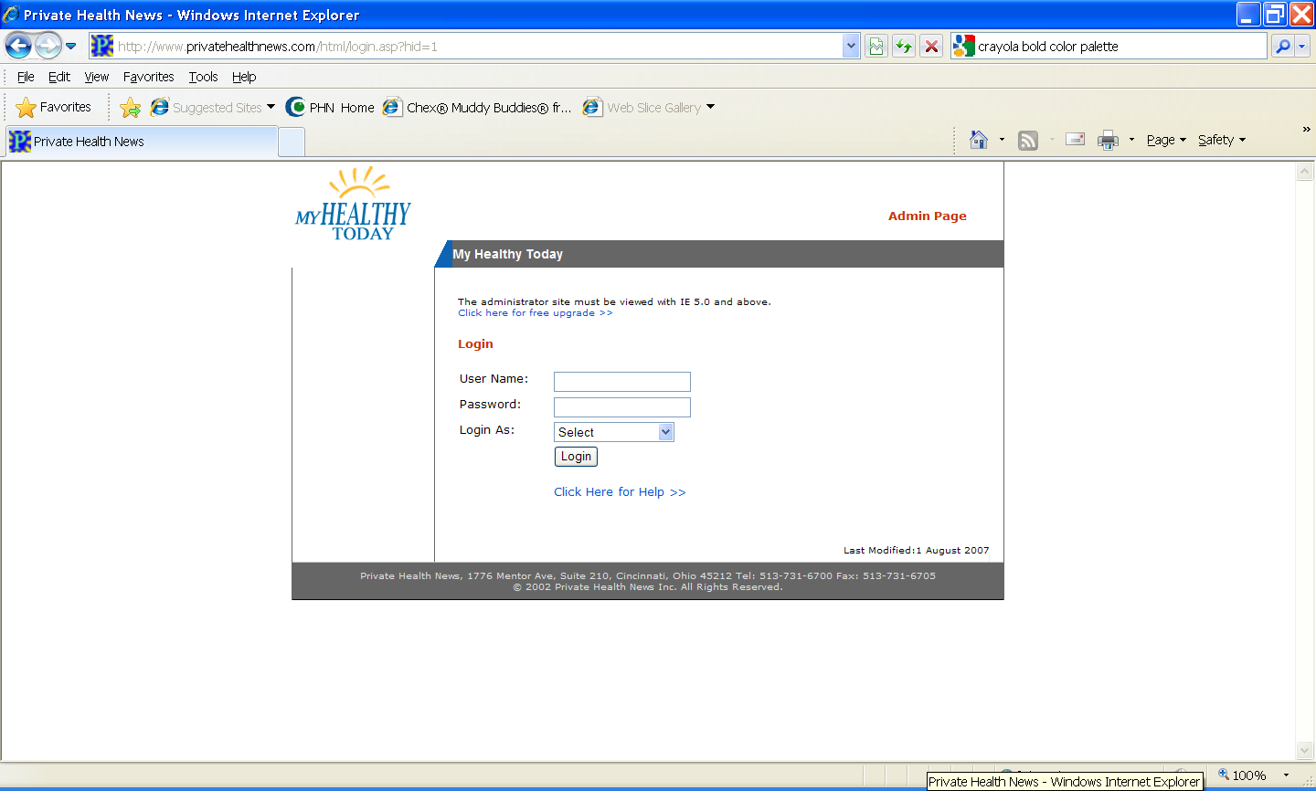

**My Login Information:**

Username:

Password:

1. Enter **User Name** and **Password.**
2. Select Login As: **Marketing.**
3. Click: **Login.**

**\* Contact Client Services for forgotten user names and passwords or to create other user accounts.**

# Marketing Menu Choices

* **My Health Newsletter Functions:**

|  |  |
| --- | --- |
| **Add General Newsletter**  **Message: Web / Email** | Think of the general newsletter message as your Headline on the web and email. Use these messages to promote special events, news, services or programs. These messages can be the same, or different. Everyone who is subscribed will view this message. |
| **Add Topic Message** | Create targeted messages for a specific newsletter topic. Only those subscribed to the chosen topic will view the message. |
| **Add Article** | * Publish an article written by your organization. * Article appears in your e-newsletter: web and email. * Only one article can be added per e-newsletter topic. * Article remains on your site until you remove it. |
| **Add Referral Source** | Feature to track marketing initiatives. This field can be used to target Easy Mail marketing messages. |
| **Health Assessment Message** | Create messages appearing on all or specific Health Assessment pages. These messages may point users to services that will help expand on what they learned from their assessment. |
| **Add Default Health**  **Reminder Message** | This feature allows one message to be inserted into all reminders-for example, a message referring to a physician directory. |
| **Add Individual Health**  **Reminder Message** | Create messages to promote your services associated with specific health screenings and immunizations. |

* **Baby Expectations Functions**

|  |  |
| --- | --- |
| **Add Baby Expectation  General Message** | Create a message for the Baby Expectations newsletter, to be viewed on both the web and email versions. Communications regarding special events, services or promotions are ideal for this space. Everyone subscribed to this newsletter will receive this message. |
| **Add Baby Expectations**  **Message** | Create messages specific to fetal and baby developmental periods or promote specific pediatric and maternity services and programs.  Customizations appear in Baby Expectations: web and email. |
| **Send Baby Easy Mail** | This allows a targeted message to be sent to subscribers of Baby Expectations at any time, based on expected or actual birth date. |
| **Add Baby Expectation**  **Email Message** | Send targeted email message on the 28th of each month based on the expected or actual due date. |

* **Website Wrap Functions:**

|  |  |
| --- | --- |
| **Update What’s New** | Create messages about new services and events.  **It is recommended that this feature always contains a message or the word “undefined” will scroll on in the What’s New box.** |
| **Add / Edit Physician** | For clients with this option, physicians can be easily added to the data base using this feature. |
| **Send Easy Mail** | Send targeted marketing email message to subscribers based on date of birth, gender, zip code, topics, or referral codes (if used). |

* **AdHoc Functions:**

|  |  |
| --- | --- |
| **Easy Mailer eList** | This feature allows you to enter email addresses that will be stored for use as a content review group. |
| **Baby Easy Mailer eList** | This is a similar feature, which allows you to store email addresses for the Baby Easy Mail messages. |
| **Message Repository** | The last five times that a message is saved is stored here. You can review General Messages and Topic Messages with this feature. |

* **Administrative Functions:**

|  |  |
| --- | --- |
| **Change Password** | Option to change password that is given by PHN. |
| **Online Web Log Report** | Reporting feature that offers statistics for activity, access, visitors and browser information. |
| **Logout** | Returns user to landing page of newsletter after marketing session is completed. |

\*\*Some of the features listed here are optional, and may/may not appear on your newsletter, depending on your contract specifications\*\*

# Message Box Basics

To create customized messages, you will use a standard toolbar and message box similar to Microsoft Word® applications. Remember to keep your message **CLEAR** and **CONCISE.** This will allow your subscribers to quickly grasp your message and read the health information for which they subscribe.

Simply insert your cursor into the message box and begin to add your customizations, such as text, images and hyperlinks. Below is an example of a typical screen used to create a message.

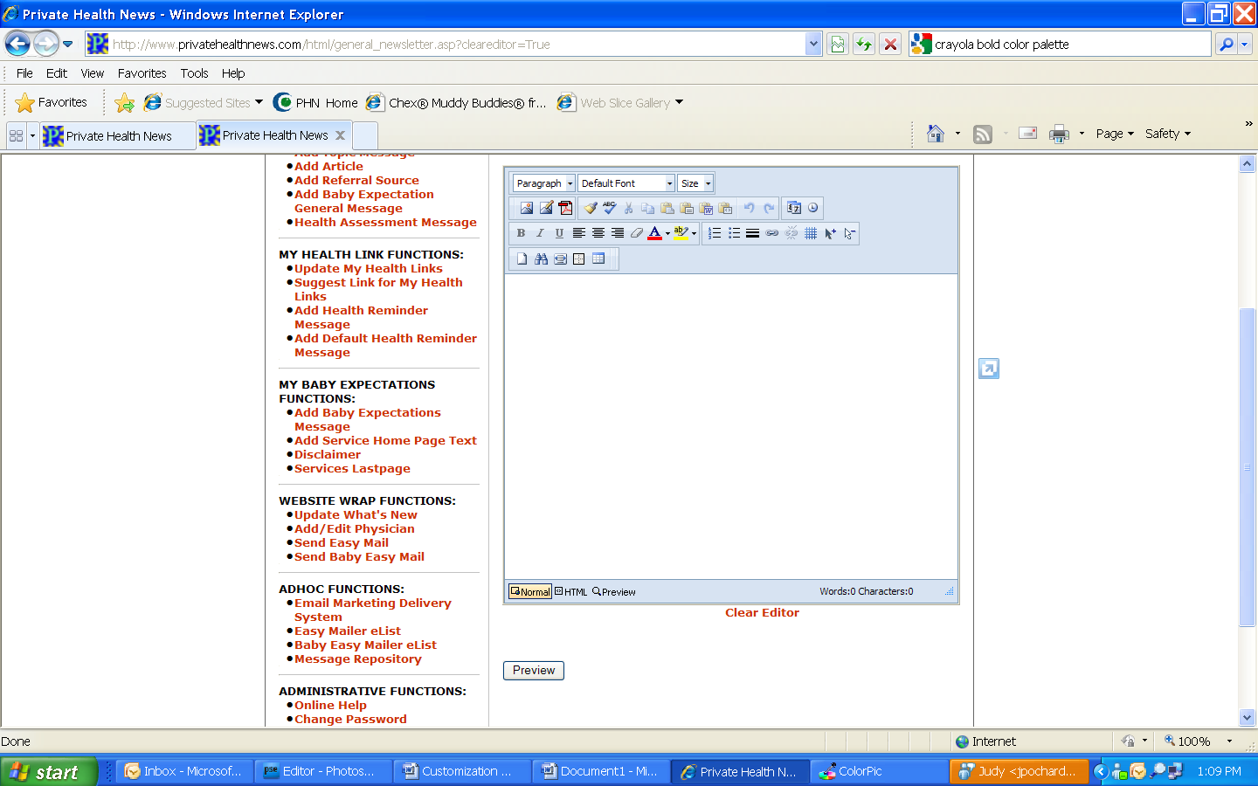

Then, use the buttons below the message box to preview and post your message to your “wrapped” site.

|  |  |  |  |
| --- | --- | --- | --- |
|  | Heading format |  | Font type |
|  | Font size |  | Image gallery |
|  | Insert image |  | Link to .PDF file |
|  | Clean up HTML |  | Spell check |
|  | Cut |  | Paste plain text |
|  | Undo |  | Redo |
|  | Insert today’s date |  | Insert current time |
|  | Bold font |  | Italicize font |
|  | Underline font |  | Left justify |
|  | Center justify |  | Right justify |
|  | Remove formatting |  | Font color |
|  | Highlight text |  | Numbered list |
|  | Bulleted list |  | Insert horizontal line |
|  | Insert hyperlink |  | Remove hyperlink |
|  | Select none |  | Select all |
|  | Find and replace |  | Toggle table borders |
|  | Insert table |  | Table properties |
|  | View HTML |  | Normal view |

* **Quick Tool Reference:**

# Insert a Table



Inserting a table is an easy way to create a layout design for your messages. Using the Insert Table icon you can quickly create and develop a table to design your messages.

* **Define the Table**



1. Click: **Insert Table** icon,
2. You can quickly select the number of rows and columns by dragging your cursor over the selection of cells you desire.

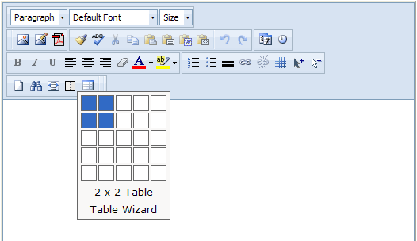

Select the Table Wizard for more detailed tables.

1. For more detailed tables, the **Table Wizard** will help you select the number, size, and layout of your cells.

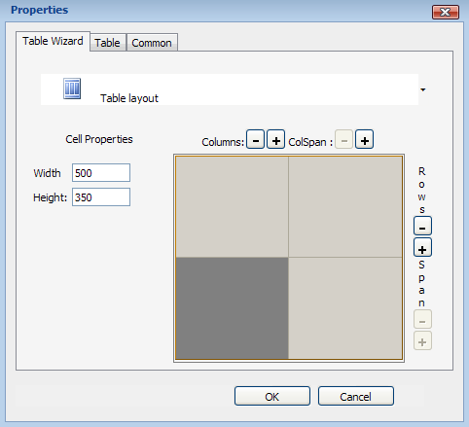

Height and width can be set to specification.

…or use the plus and minus buttons to format your rows and columns manually.

Click Table layout for a list of pre-set table templates…

1. Your inserted table will appear in the editor.

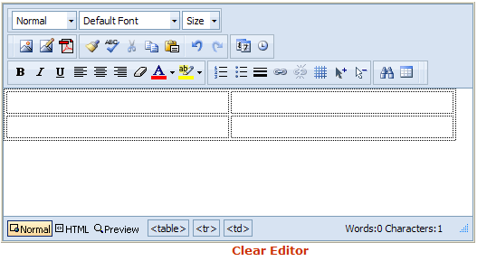

* **At any time, you can edit the table.**

1. Once you have created your table, you can make changes to it easily:
   1. Place your cursor within the table you want to edit.



* 1. Click the table tag at the bottom of the editing frame, and then select **Properties** from the menu that appears.
  2. Select the Table tab.

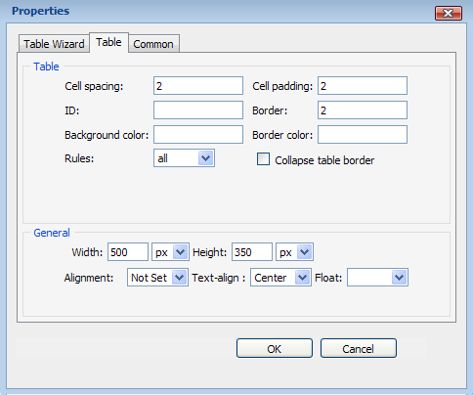

You can also make changes to table dimensions and alignment.

Insert hex codes to select border and background colors, or click the text field to view a color palette.

Cell spacing and padding refers to the amount of space between the edge of text and graphics, and the sides of your cells. Less space gives the appearance of a tight squeeze!

* **Helpful Hint!**

You may notice that even after you set your table borders to your desired thickness and color, they still show as a black double-line in the editor. These are the ‘working borders’ that show your cell layout, spacing and padding. To see the borders as they will appear in your message, click the Toggle Table Borders icon.



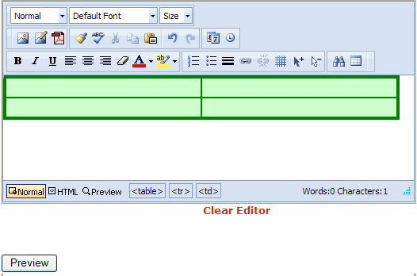

# Insert Images

Using images in your messages will help catch your subscribers’ attention. Images can be clip art, photos and graphics. Acceptable image formats are:

1. Joint Photographic Experts Group – .jpg
2. Graphics Interchange Format – .gif

Save the image you want to use to a folder on your computer. File names should be limited to 10 characters using letters, numbers and the underscore key only. No spaces or special characters should be used.

There are two ways to insert an image:



1. Select: **Image Gallery** icon . The **Insert Image** window will open.

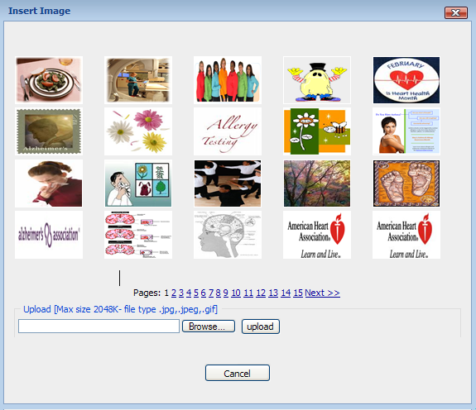

* 1. Click: **Browse**.
  2. Locate your image on your computer.
  3. Choose image and click: **Open**. The image’s file path will appear in the text field to the right of the Browse button.
  4. Once the file path is inserted, click: **Upload**.
  5. The image will upload and its thumbnail will appear in the gallery.

* 1. To use an image that has been previously uploaded, click the image thumbnail. **Note**: the image will insert as-is. There are no options for formatting photos in the **Image Gallery.**



1. You can also add an image to your message by clicking the **Insert Image** icon.
   1. A more detailed **Insert Image** window will open:

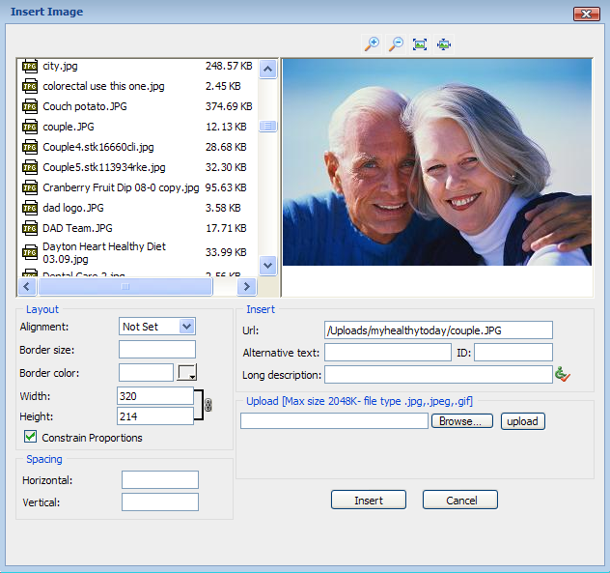

You can upload images from this menu as well.

Link to an image if you prefer.

Dress up your image by adding a border or aligning it in an eye-catching way. Also resize images before placement.

Clicking a file from the library will produce a preview to the right.

* **Helpful Hints!**
  + - 1. You may want to upload files of your logos, graphics, and pictures of your facility that you use on your website. In addition, you can save electronic media that you use in events to use in the newsletter. Simply save the files as .jpg or .gif files, sizing them appropriately, and upload them into the graphic library. Most of the successful messages are approximately 3”X 5” in size, including text and pictures.
      2. If at any time you see a red “X” where an image had previously appeared in a message, this is an indication that the graphic used has been removed from the library. You may choose to upload it again, or choose a different image.

* + - 1. Other reasons that graphics don’t work properly are that they are saved as the wrong file type, have a file name that is too long, or contain special characters. Try re-saving your picture as a .jpg or a .gif file with a name of no more than 10 characters - preferably letters and numbers only, no spaces. Upload the image again, and then delete the file that doesn’t work.
      2. Images can be resized by pixel count and also aligned in the editor.

# Insert a Hyperlink

Inserting hyperlinks in your customized message brings the subscriber to targeted information residing on your main website, such as to physician locators, community education calendars, and registration forms.

1. **Open** two Internet sessions.
   1. Open the first session to the page where you want to take the subscriber.
   2. The second session is open to your Administration Site and the message box where you want to create the hyperlink.
2. From the first Internet session, **select** **and copy** the entire web address out of the address bar that you want to insert into your customized message.

**Note: For best results, use sites that do not use cookies.**

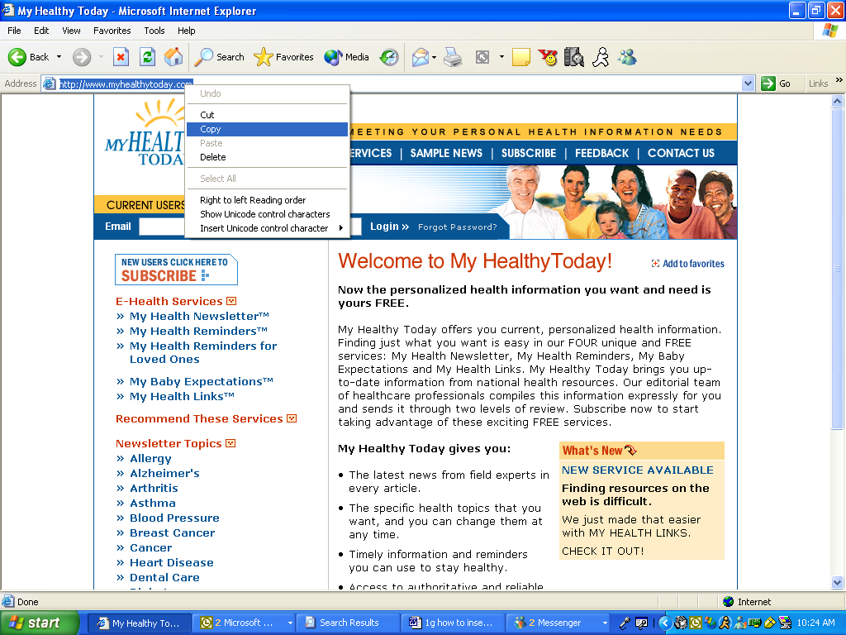

1. Insert the hyperlink into your message box.
   1. Highlight the text or graphic that you want to be the hyperlink.



* 1. Select: **Hyperlink** icon . A **Hyperlink** window opens.
  2. Insert entire Internet address into **URL** field and choose the Target - same window, new window, etc.
  3. Select: **OK**.
  4. The Internet link will be hidden behind the object you had highlighted - words, graphic, etc.

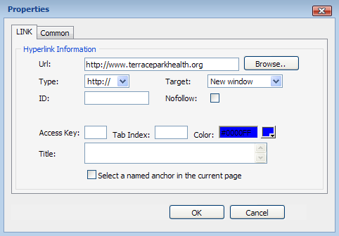

Targeting links to a new window allows readers to return to the newsletter easily when they are finished with the linked site.

Specify a link type if you are linking to an email address or a secure server (https://).

# Link to a .PDF

In addition to linking to secondary websites, you may also store items with PHN as a .PDF (Adobe Acrobat) file and link to that document.

1. Upload your .PDF file.



a. Click the **Insert .PDF file** icon.

b. The Downloadable Files window will open:

c. Click: **Browse**.

d. Locate the desired .PDF on your computer.

e. Choose the file and click: **Open**. The image’s file path will appear in the text field to the right of the Browse button.

f. Once the file path is inserted, click: **Upload**.

g. The file will upload and will appear in the downloadable files library.

2. Link to your .PDF

a. Highlight the text or graphic you would like to use as the link.



b. Click the **Insert .PDF file** icon.

c. The Downloadable Files window will appear.

d. Select the file you would like to link to (when selected, file information will show in the preview box to the right of the file library).

e. Click **Insert**.

f. A link to your file will be hidden behind the object you highlighted - words, graphic, etc.

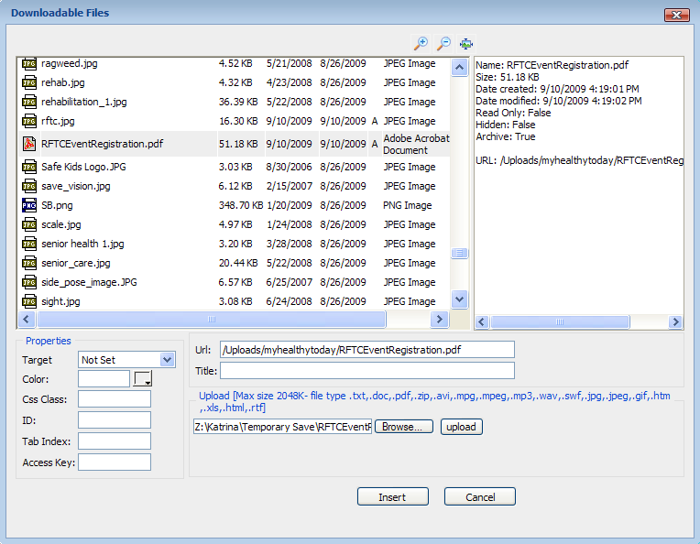

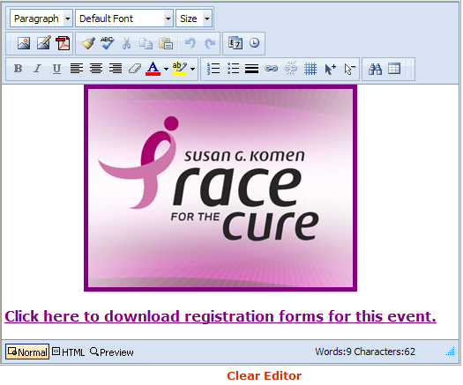

Parent/ Child Message **(Option)**

**Important Note: The term Parent/Child is used in this illustration to mean a corporate Parent and Subsidiary relationship.**

Depending upon your contracted services, your organization may have parent/ child relationships. A parent/ child relationship enables the main contracted organization (parent) the ability to determine how their members (children) are able to create messages.

Parent/child relationships are assigned and maintained only on the parent’s Administration Site. The parent controls the child’s ability to create messages on different levels of the “wrapped” site, such as the general newsletter, What’s New and specific topics. If multiple children exist, the parent can assign unique message privileges to each child.

Assignments are made using this control panel located at the bottom of every message box screen:

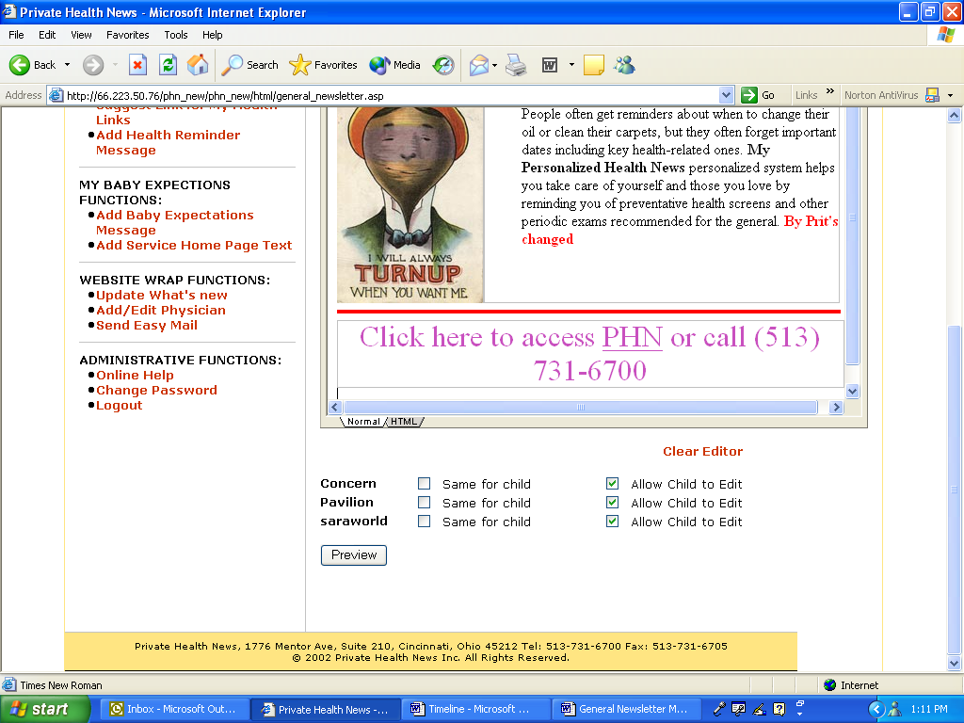

North Hospital  
South Hospital  
East Outpatient

Member 1

Member 2

Member 3

Each member must have a checkmark in either **Same for Child** or **Allow Child to Edit**.

|  |  |
| --- | --- |
| **Same for Child** | Child is unable to create own messages for a particular feature on the child’s “wrap”. The message in the parent’s Administration Site will appear on the child’s “wrap”. |
| **Allow Child to Edit** | The parent allows child to create own messages for a particular feature on the child’s “wrap”. |

Checking both options will give the child’s wrap the message of the parent, but the ability to edit if they choose.

# General Newsletter Message: Web/Email

The **Add General Newsletter Message: Web/Email** feature allows you to create Headline messages for your newsletter on the “wrapped” site and monthly email. There is only one e-newsletter, but the two versions can have two different marketing messages.

* **General Newsletter Message: Web**The message subscribers see when they come to the website and sign in. Visitors to the site also see the message when coming to the landing page and clicking on any topic. These messages change in real time, so as soon as the messages are updated, they are available.

**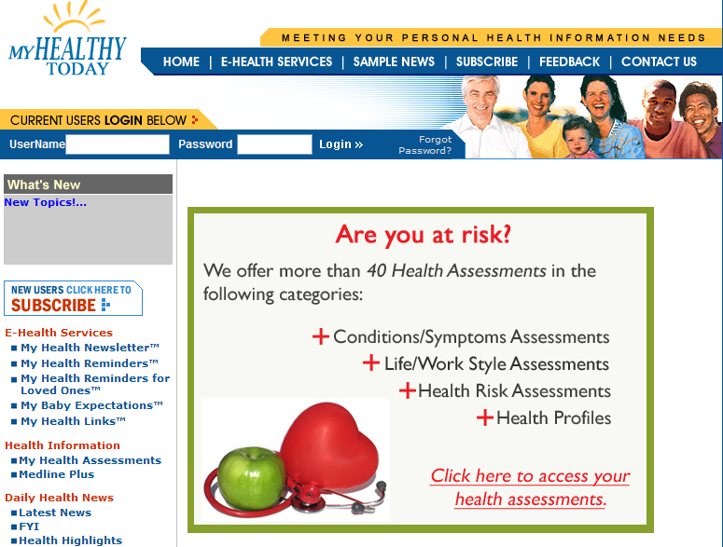**

Message as it is viewed on the website.

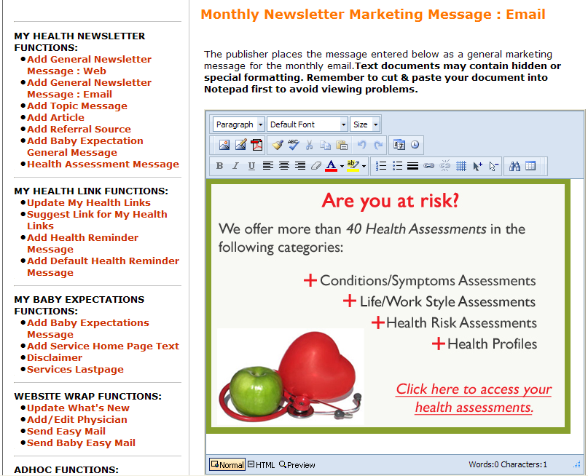

Message as it was inserted in your admin panel.

* **General Newsletter Message: Email**

This message is incorporated into your monthly email newsletter and delivered to your subscribers starting on the 1st day of every month. The email message is usually a time-sensitive message, and is a great place to put marketing information for seminars, classes, events and fundraisers. You may also choose to make this message the same as the General Newsletter Message: Web. This is the only customization that is seen in the initial newsletter that is received upon subscription.

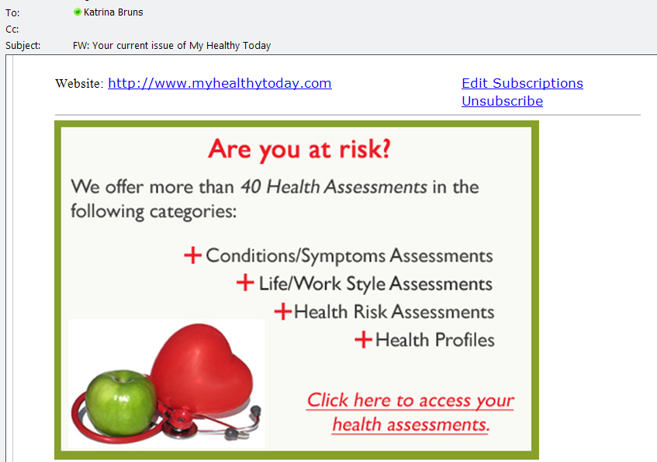

Message as it is viewed in the monthly email - Changing the email message each month will keep subscribers interested.



Message as it is inserted in your admin panel.

Add General Newsletter Messages: Web/Email

When starting to add General Messages, decide which you will change. If you will be changing both the Web and Email messages, and they will be different, then it does not matter in which order you work. However, if you want them to be the same, start with the Web message - there is a helpful button to copy the message to the email version.

Click: **Add** **General Newsletter Marketing Message: Web/Email**.

1. Create your message using the standard message box and toolbar. Insert images, text and hyperlinks. If you are replacing an existing message, begin by clicking “Clear Editor” to remove all components of the previous message.

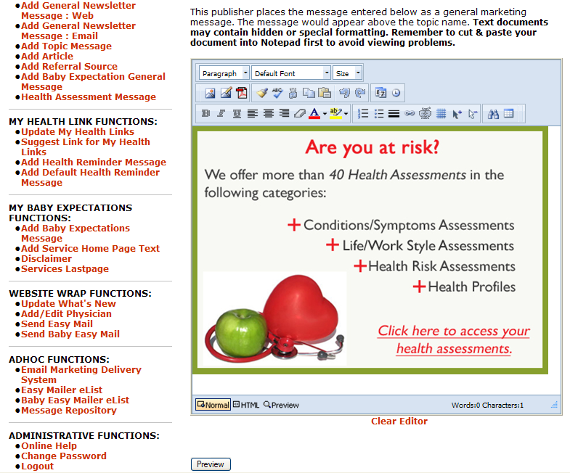

1. Click: **Preview** when you have finished adding all of your marketing components.

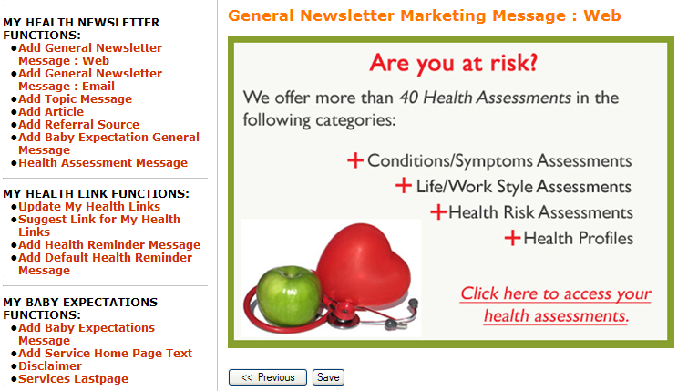

1. Review your message. You can check your hyperlinks from this screen.
   1. Click: **Previous** to make changes.
   2. Click: **Save** to publish your message.
2. If you have created a Web message, you can now go to the browser where your “wrapped” site is open, click on “refresh” and view and test your message.
3. If you are now creating the **General Newsletter Marketing Message: Email** message, you can use the same steps as before.
   1. The **General Newsletter Marketing Message: Email** has the option of the “**Same as Web**” button, which copies your web message over automatically. If your plan is to have your messages match, this button will save time.   
      **Important Note:** Be sure to Preview & Save your message, even when using the “Same as Web” feature!
   2. If you are creating a new message for the email version of the newsletter, ignore this button.

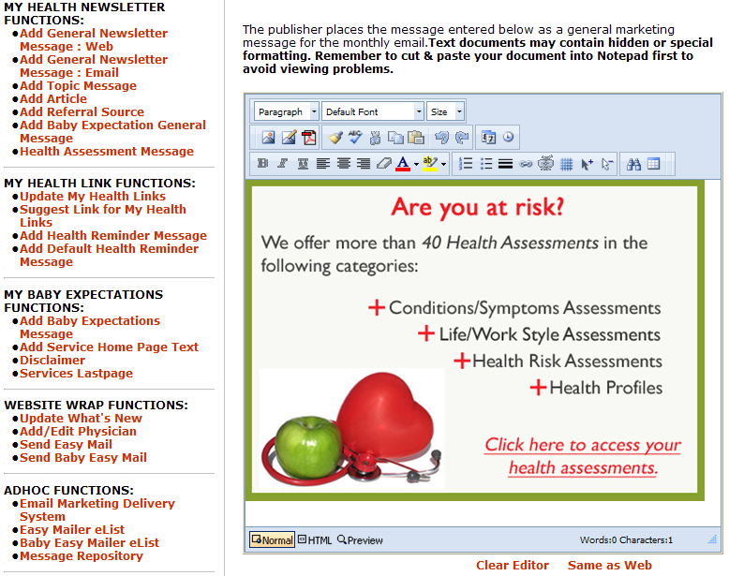

1. Review your message by clicking the **Preview** button. You can check your hyperlinks from this screen.
   1. Click: **Previous** to make changes.
   2. Click: **Save** to publish your message.

Topic Marketing Message

* **Add Topic Message**:

This feature allows you to attach marketing messages to each e-newsletter topic that you choose. The Topic Message appears just beneath the topic heading on the e-newsletter, and is viewed on both the website and the email versions of the newsletter (except for the initial email at subscription.)

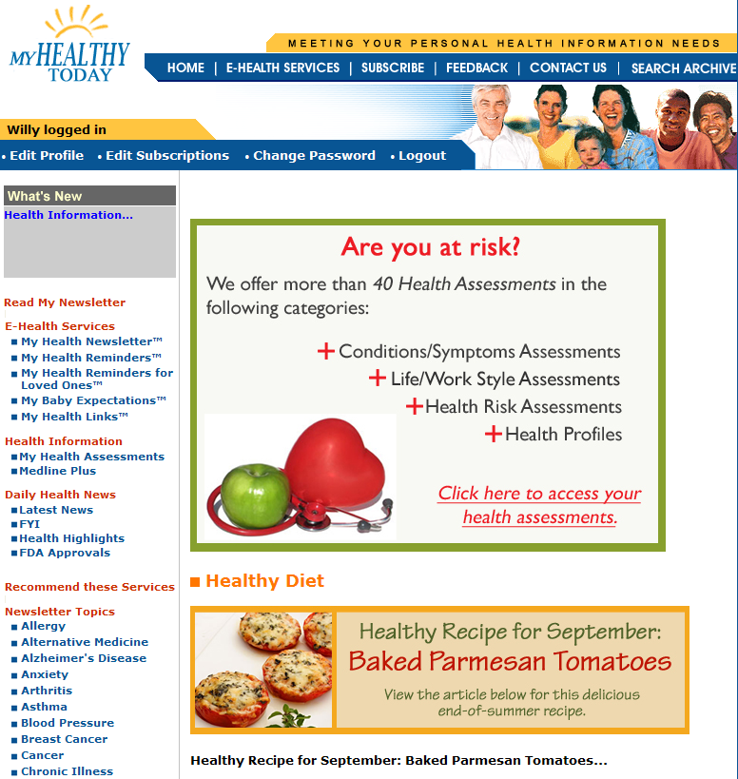  
  
(Web version, showing General Message, then topic heading and Topic Message)

1. Click: **Add Topic Message** from the menu.
2. Using the **Select Topic** dropdown menu, select your newsletter topic.

**Select Topic** allows you to choose the topic that you’d like to customize.

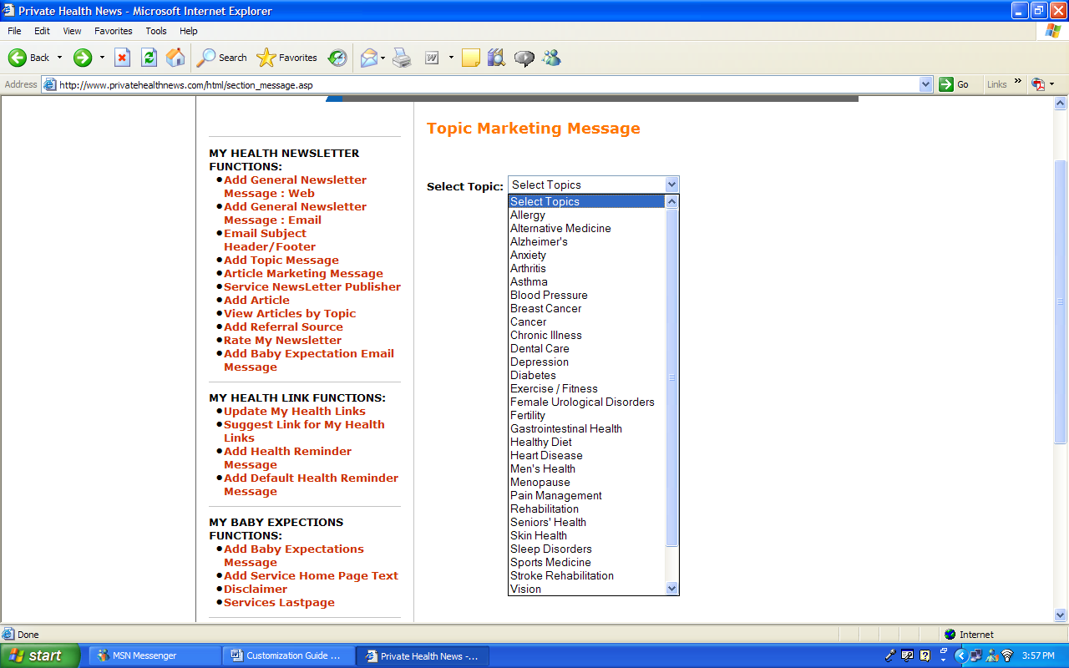

1. Create your marketing message using the standard message box and toolbar.

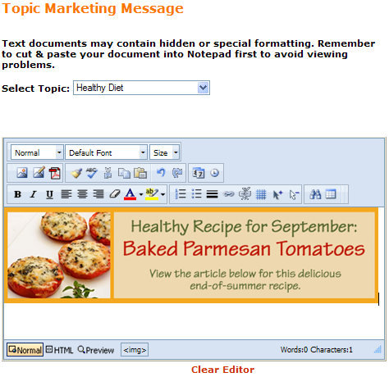

1. Click: **Preview** to view your message and test hyperlinks.
2. Review your message. You can check your hyperlinks from this view.
   1. Click: **Back** to make changes.
   2. Click: **Save** to publish your message.
3. **Open** and **Refresh** your PHN service and select newsletter topic. View your message and test your hyperlinks.

* **Helpful Hint!**

To insert the same message in multiple topics, replicate the message by copying the HTML code and pasting it into the HTML viewer for each additional topic. Messages can be saved indefinitely as HTML code on a Notepad® or WordPad® document. Click on the HTML view at the bottom of the editing window. Highlight the entire code that is now in the frame. Go to a Notepad® or WordPad® document and paste the code, then save the document. Saving messages this way will save your formatting, hyperlinks and images. If a message is designed for an event that occurs repeatedly, you’ll only need to edit the date and time!

To easily view your customizations, be sure you have all e-newsletter topics selected as part of your own subscription, so that you will see the messages as your subscribers view their email. Keeping your e-newsletters in a file will also give you a reference for your messages.

# Add Article

**Add Article** publishes articles authored by your organization to your “wrapped” site. This is an excellent way to promote your research and services. Articles that you add to the e-newsletter always take the marquee position over articles that are supplied by PHN.

* One article can be added to each newsletter topic.
* Articles appear in your monthly email and on the website.
* Articles will remain as part of your service until you delete it from your Administration Site panel.
  1. Select: **Add Article** from left-hand menu options.
  2. Using **Select Newsletter**, assign the article’s newsletter topic from the dropdown list.

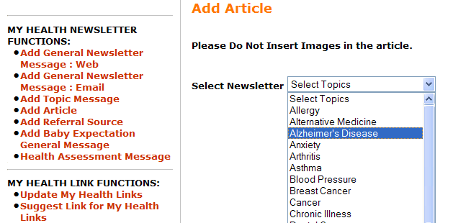

**Select Newsletter** assigns your article to a topic.

1. Click on **Add New,** to add the new articles

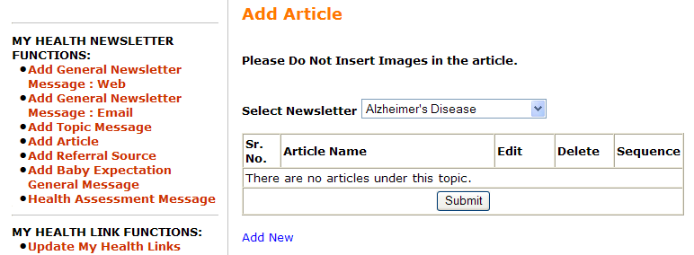

1. Add the article.
2. Type in the article **Name**.
3. Type in the **Created Date** which is the date the article was published.
4. Type in the **Source** which is the author or publisher.
5. Insert **Body of Article** into message box using the cut/paste method from Notepad®.
6. Click: **NEXT** when complete.

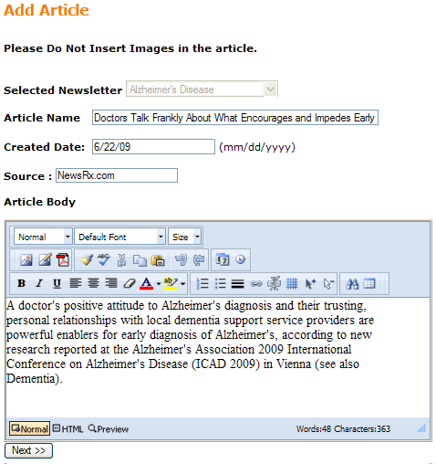

1. Unlike the **Topic Messages**, the **Add Article** feature offers an additional editing frame (shows when you click next) so you can create a marketing message for the article. The marketing message can include text, a graphic such as a logo, or a hyperlink, or a combination of all three!

If you choose *not* to insert an additional message after your article, simply leave the additional frame blank.

1. Click: **PREVIEW** to view entire article, including article title, body and marketing message.
2. Click: **SAVE** topost your article. A confirmation pop-up window appears.
3. Your article has been added.
4. To **Edit** the article Click on the word Edit
5. To **Delete** the article Click on Delete
6. **Open** and **Refresh** your “wrapped” site. View and test your article insertion in two locations:
7. Read My Newsletter b. Under the assigned newsletter topic

* **Helpful Hint!**

The **Marketing Message** appears at the bottom of your article on the computer screen, in the email if forwarded to a friend, and on the paper if printed. If you’ve included your website address or logo, your branding will follow your article, creating a viral effect for your newsletter message.

# Add Referral Source

**Add Referral Source** allows you toadd sources where readers have heard of your e-newsletter. Although the field is not mandatory upon subscription, the down arrow provides subscribers with an easy selection of choices of sources. Should you choose to use this field, it provides you with an excellent method of tracking whether promotional efforts have been successful. Referral sources become part of the subscription process immediately after they are entered and remain until deleted. Reporting can be requested from Client Services to give totals for each source listed. In addition, this field can be used as a parameter for sending Easy Mail.

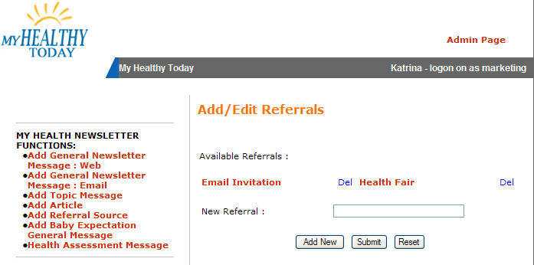

**To add a Referral Source:**

1. Type the title you wish in the **New Referral** box
   1. Click: **Add New** if adding a new referral source
   2. Click: **Submit** if editing an existing referral source
   3. Click: **Reset** to eliminate the referral source that is entered in the
      1. “Edit Referral” box and begin again.
2. **To delete a referral source when a marketing initiative is over:**
3. Click: **Del** next to the referral source that you want to remove.
4. When prompted “Are you sure you want to delete the selected
   1. Referral, click “**Ok”**.

# Add Baby Expectations General Message

The Baby Expectations General Message is incorporated into your monthly email newsletter and delivered to your subscribers on the 28th day, at midnight of every month. This message appears at the top of each month of the Baby Expectations newsletter, and can be made the same as the **General Message: Web/Email** messages by using the “Same As Email Message” button under the editing frame.

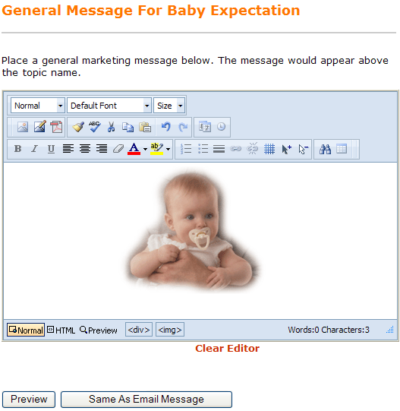

1. Creating your Baby Expectations General Message:
2. Create your message using the standard message box and toolbar.
3. Insert images, text and hyperlinks. Click: **Preview**.
4. Review your message. Click: **Previous** to make changes. Click: **Save** to publish your message to your “wrap”
5. After you click **Save**, you will receive a verification prompt to post the message. Click: **OK**
6. Open and Refresh your “wrapped” site. View and Test your customizations.

# Add Health Assessment Message

The Health Assessment Message is a powerful way to drive subscribers to your service lines. Each Health Assessment can have a customized message. Once a subscriber has completed a health assessment, you may want to direct them to the hospital service line specific to that assessment.

To Add a Health Assessment Message:

* 1. Select “**Health Assessment Message**” from the left-hand navigation menu.  
       
     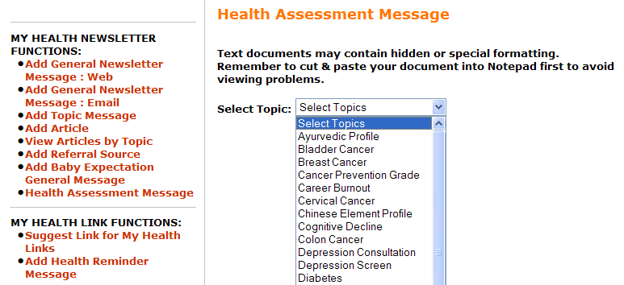
  2. From the drop-down menu, select the Health Assessment to which you want to add your message.

1. Create your message using the standard message box and toolbar.
2. Insert images, text and hyperlinks. Click: **Preview**.
3. Review your message. Click: **Previous** to make changes. Click: **Save** to publish your message to your “wrap”
4. Open and Refresh your “wrapped” site. View and Test your customizations.

# Add Baby Expectations Coordinator Message

Just beneath the monthly graphics for the Baby Expectations newsletter, is a space that is intended for a personalized message from the Childbirth Coordinator. This space, as in all of the message opportunities, can incorporate a picture, text, hyperlink or other call to action. This message can be inserted individually, by month. In addition, for your convenience, you may place a message in month 1, and copy to all other months that you choose.

* 1. To add the Baby Coordinator Message:

1. Create your message using the standard message box and toolbar. Using a table will force your image to automatically move for the text to fit in an additional cell.
2. Insert images, text and hyperlinks. Click: Preview.
3. Review your message. Click: Previous to make changes. Click: Save to publish your message to your “wrap”
4. Open and Refresh your “wrapped” site. View and Test your customizations.

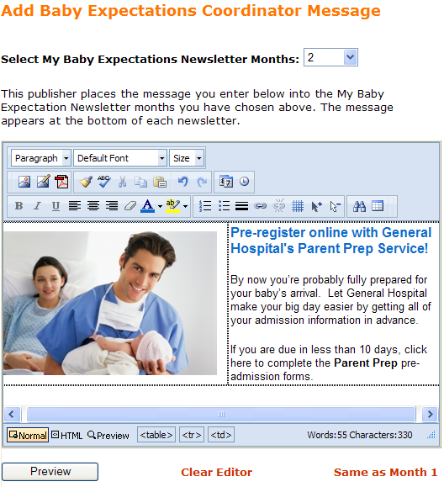

# Insert Baby Navigation Bar Links

In addition to the message areas of the Baby Expectations newsletter, you also have the ability to add links that will return your readers to pages of your own site. Web nurseries, online physician finders, online tours and registration are just some suggested uses for these links. The first two links in this area are devoted to lullabies and podcasts, provided by PHN. You may insert up to six additional links. If no links are added, lullabies and podcasts still remain.

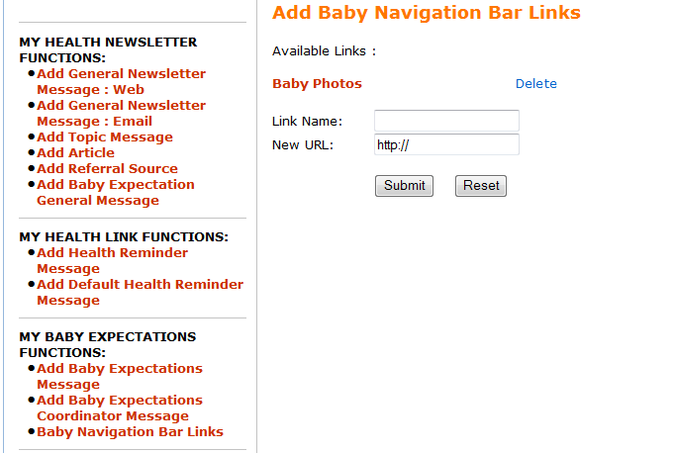

* + 1. **To add a Navigation Bar Link:**
  1. Type the title you wish in the **Link Name** box
  2. Add the URL to the **New URL:** field. You may cut/paste this directly from the address bar, or type directly into the field.
  3. Click: **Submit.**
  4. Click: **Reset** to eliminate the referral source that is entered in the “Edit Referral” box and begin again.

1. **To delete a Navigation Bar Link:**
2. Click: **Del** next to the link that you want to remove.
3. When prompted “Are you sure you want to delete the selected link, click “**Ok”**.

# Add Baby Expectations Monthly Message

**Add Baby Expectations Message** creates messages for each month of baby’s fetal development and the 12 months of baby’s first year.

1. Click: **Add Baby Expectations Message**.

**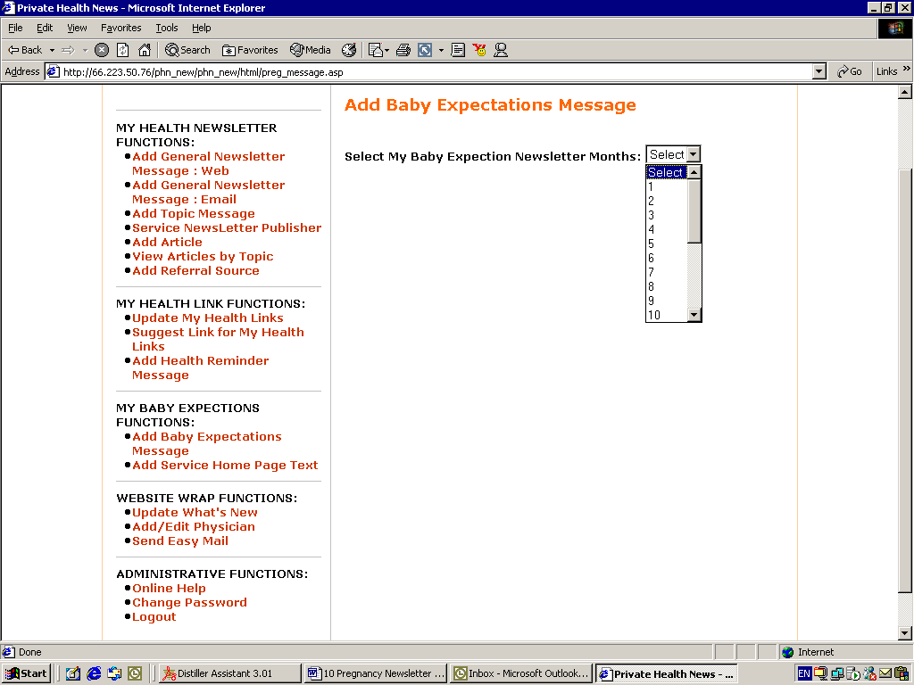**

1. Click: **Select My Baby Expectation Newsletter Month** and choose the development month for your message placement.

Development Month Conversion Chart

Administration Newsletter Number

|  |  |  |  |  |  |  |  |  |  |  |  |  |  |  |  |  |  |  |  |  |
| --- | --- | --- | --- | --- | --- | --- | --- | --- | --- | --- | --- | --- | --- | --- | --- | --- | --- | --- | --- | --- |
| **1** | **2** | **3** | **4** | **5** | **6** | **7** | **8** | **9** | **10** | **11** | **12** | **13** | **14** | **15** | **16** | **17** | **18** | **19** | **20** | **21** |
| **1** | **2** | **3** | **4** | **5** | **6** | **7** | **8** | **9** | **1** | **2** | **3** | **4** | **5** | **6** | **7** | **8** | **9** | **10** | **11** | **12** |

Pregnancy Month First Year of Life

1. Create your message using the standard message box and toolbar.
2. Click: **Preview** at the bottom of the page to review your message.
3. Review your message.
4. Click: **Back** to make changes.
5. Click: **Save** to publish
6. **Open** and **Refresh** your PHN service. View and test your customizations.   
     
   **Note:** The best way to preview all development newsletters is to have your delivery date be one year from today’s date. For example, if today’s date is 1/1/2012, then create your delivery date for 1/1/2011.

# Add Default Health Reminder Message

The **Add Default Health Reminder Message** enables you to add the same customized message to all My Health Reminders and My Health Reminders for Loved Ones. This feature allows the same message to be added to all immunizations and screenings with one entry, without having to copy and paste each message individually, i.e., when entering a message for a Find a Physician to all screenings.

**Note: This feature will overwrite all of the previously existing messages that have been entered in the Health Reminders.**

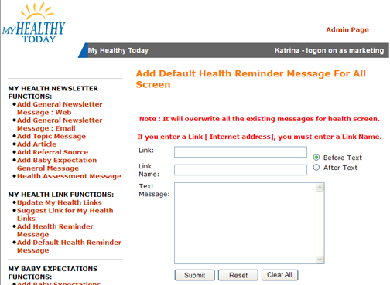

1. Click: **Add Default Health Reminder Message** from the left-hand navigation.

1. Enter the message, either directly into the editor, or by cutting and pasting from Notepad.
2. If adding a Link, a Link Name must also be used.
3. Click on **Submit**, or **Reset** if you are editing an existing message.

* **Helpful Hint!**

Make sure that this reminder is set up first and edited completely before moving on to designing any specific reminders. Making changes to the Default Health Reminders message will overwrite all other messages that you have set up.

# Add Individual Health Reminder Message

The **Add Individual Health Reminder Message** allows you to customize health messages individually for screenings and immunizations. For messages that you wish to create repeatedly, you may wish to use the Add Default Health Reminder Message first, and then use this feature to tweak a few specific messages.

To add a message:

1. Click: **Add Individual Health Reminder Message** from left-hand menu option.

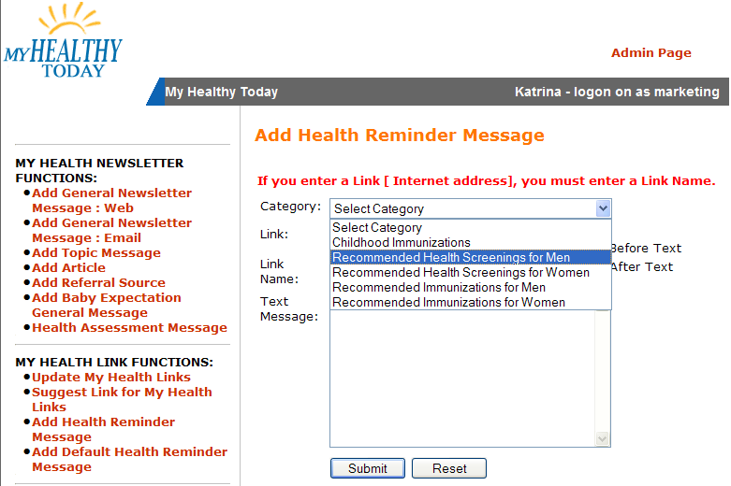

1. Select: **Category.** Category assigns the type of health reminder.
2. Select: **Sub Category**. Subcategory assigns your message to a specific immunization or screening. The current message, if any, will be shown. If the Default Health Reminder Message was used, this will be displayed.
3. Create your message and enter a link if you choose. Customization is restricted due to the limited space available for the message.  
     
   **Note:** If you enter a **Link** (internet address), you must enter a **Link Name**.

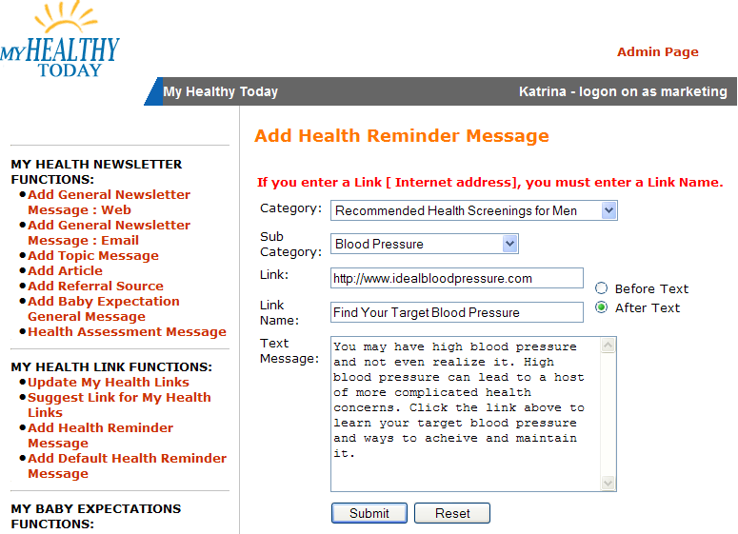

* **Helpful Hint!**

You may choose to leave the link from the Default Health Reminder in place-for example, to your Find a Physician - and change only the message. Changing messages creates a less redundant look for the subscribers who are in an age group that may receive several Health Reminders.

1. Review your message.
   * 1. Click: **Submit** to save your changes.
     2. Click: **Reset** to restore existing message.
2. **Open** and **Refresh** your “wrapped” site. View and test your message.

# Update What’s New Message

**Update What’s New** allows you to add, edit or delete your What’s New messages on your “wrapped” site. Use to spotlight upcoming events and current happenings.

1. Click: **Update What’s New**.
2. Decide your What’s New need and select its related call-to-action.

|  |  |
| --- | --- |
| **Add New Message** | Click: **Add a Message**. Complete the form.  (\*) are required fields. |
| **Edit** | Click: **Edit**. Update the pre-filled form. |
| **Delete** | Click: **Delete**. Your message will be removed. |

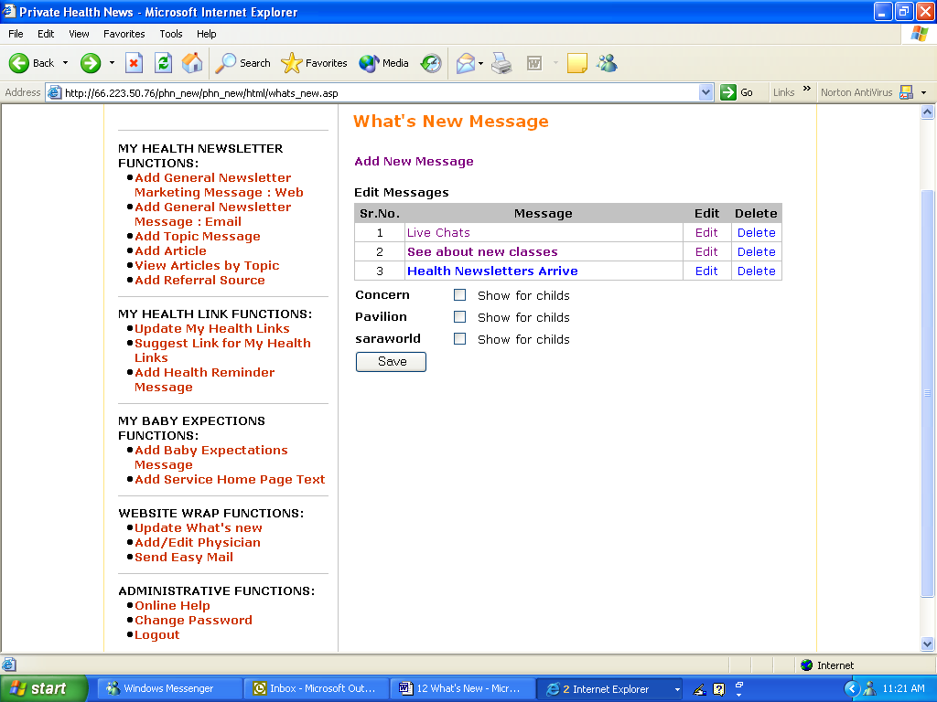

Message order on the Administration Site is equal to the scroll order in the What’s New box on your “wrap” site.

Message order on the Administration Site is equal to the scroll order in the What’s New box on your “wrap” site.

Message order on the Administration Site is equal to the scroll order in the What’s New box on your “wrap” site.

To **Add/Edit** a What’s New message, you will use the following required fields: title**, heading and body**. You can use a hyperlink at the top of the message and at the bottom. The hyperlinks can be the same or different. You may also choose to use the space for an announcement only, in which case the spaces will collapse.

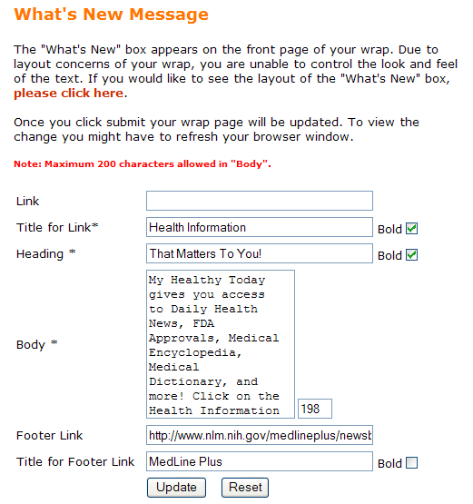

This is how the message will appear on your wrap site.

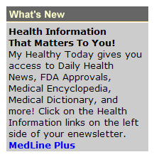

1. Click: **Add New Message** or **Edit**.
2. Create or revise your text message. Customization is restricted due to the limited space available for the message. Text is limited to 200 characters and a counter box is provided for your convenience.
3. Decide to save your changes.
   1. Click: **Submit** to accept your changes.
   2. Click: **Reset** to return your existing unchanged message.
4. Preview your What’s New message.
   1. Click: **Back** to make changes.
   2. Click: **Submit** to post your message to your “wrap” site.
5. **Open** and **Refresh** your PHN wrap. View and test your What’s New messages on your “wrapped” site in three locations.

* **Helpful Hint!**

There is no limit to the number of messages that you can insert, but PHN recommends no more than four at a time - people won’t stare indefinitely!

If using a link at the top of the message, the Title will scroll in the upper left-hand corner. If you choose not to use a link at the top, the Heading is the line that will scroll after logging into the newsletter. Make sure that these lines contain enough detail to make sense - for example: “Registration Form” instead of “Click Here.”

# Send Easy Mail

**Send Easy Mail** enables you to send targeted emails to your subscribers based on their e-newsletter topic interests. For example, **Easy Mail** allows you to send an email to all of your female subscribers, age 35-60, who live in a specific zip code, who attended your health fair, that are subscribed to Diabetes. It’s easy to set up and there is no extra charge for you to use this feature!

1. Select: **Send Easy Mail** from the left-hand menu option list.

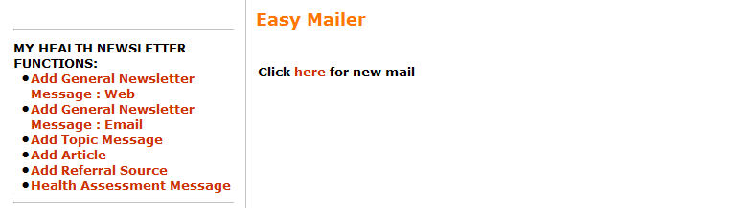

1. To create a message choose one of the options below:
   1. **Add** a new email. If messages have already been sent, they will be presented in a table, as below.
   2. **Edit** an existing scheduled email.
   3. **Delete** an existing email.
   4. **Click Here** for a new mail.

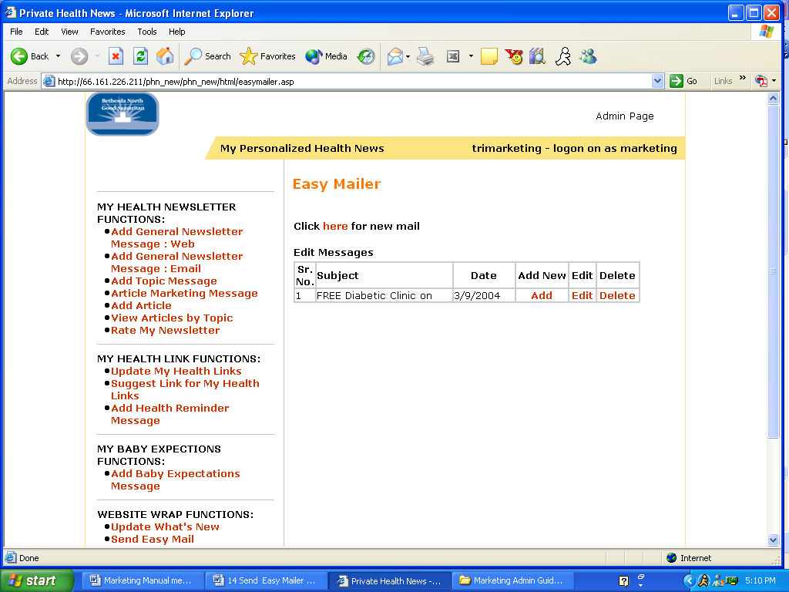

1. Define email recipients:
   1. Create the **Subject** of your email.
   2. Select a **Date of Publication**. This determines when your email is sent to your subscribers. Easy Mail messages are sent at 12:30 AM, EST the date you choose, to insure they arrive in your recipients’’ inboxes in a timely manner.
   3. Select the **Gender** tha*t you’d like to target. You can choose Female, Male or Both.*
   4. *Select the* ***Age Group*** *of th*e marketing initiative. The fields default to everyone; however you can change the dates to whatever you wish.
   5. Choose **Zip Code** if you would like to narrow the field of subscribers who receive the email. If this field is left blank, the system will ignore this field. To add multiple zip codes, separate each code with a comma.
   6. The **Referred By** field uses the Referral Sources that you have added. Using these choices, you can target people who attended a health fair, came through your website, etc.
   7. By choosing **Topics**, you can select subscribers who are interested in the specific health interests that you are targeting. Or you can use the “Select All Topics” button to choose your entire data base.  
        
      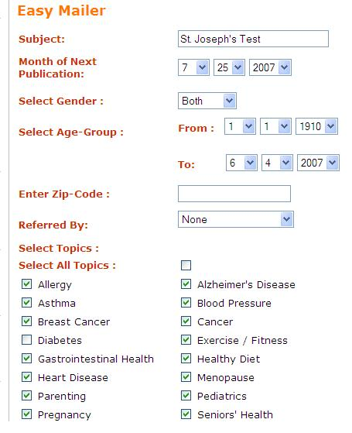
2. Queue email to be sent:
   1. **Send to review** - Send email to specific addresses for review.
      1. Enter one email address in each address field (limit of 12).
      2. Click: **Send to Review**. This saves and queues the email to be sent.
      3. **Note:** When using a review group, there are 3 differences to the Easy Mail messages:
         * No salutation will be used as in the messages to your subscriber base.
         * The messages will be sent immediately, regardless of the date you chose, giving you the ability to edit the message.
         * The people that you choose for the review group do not need to meet the criteria that you choose for the “real” message. The email addresses do not need to be subscribed to the newsletter.

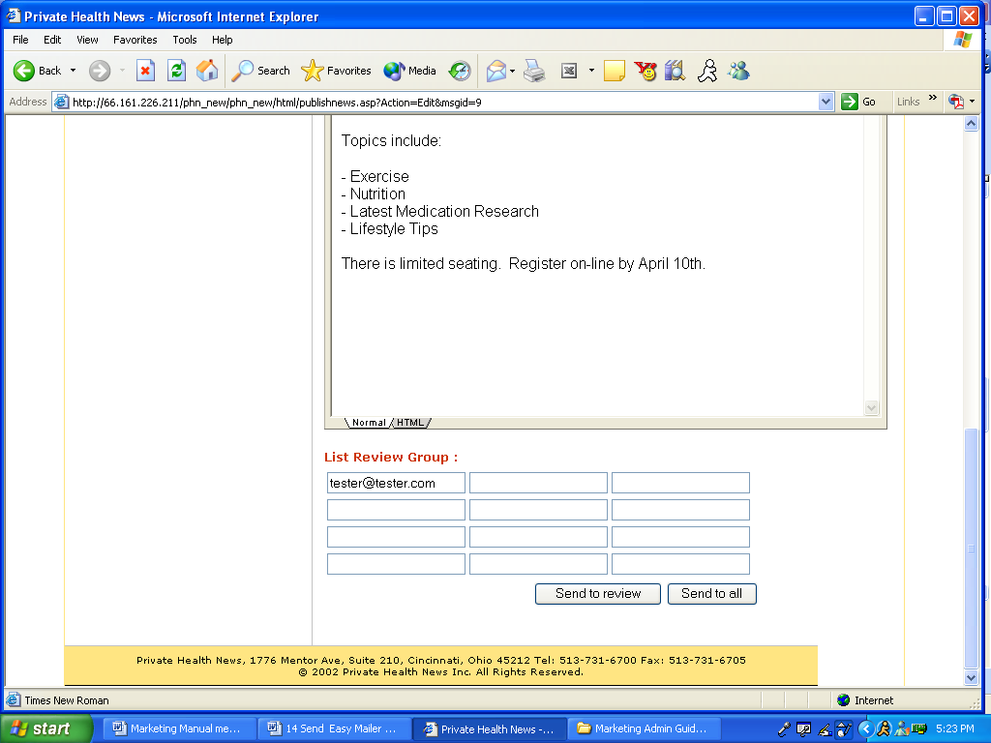

1. **Send to all -** Send to subscriber groups based on parameters that you have chosen.
   * 1. Click: **Send to All**. This saves and queues the email to be sent. The email will be sent out at 12:30 AM, EST on the date selected. If you need to cancel or edit the Easy Mail, you can do so until 11:00 PM, EST the day before the Easy Mail is scheduled to send.
     2. **Note:** If a subscriber is registered for several selected e-newsletter topics, the subscriber will receive only one email

* **Helpful Hint!**

If you are setting up an Easy Mail for an event, you can easily set up a reminder by clicking on the message after you are finished, editing the date, editing your   
message and saving again. You could set several messages in one sitting very quickly this way.

# Send Baby Expectations Easy Mail

If your contract includes the Baby Expectations newsletter, you will have the ability to send Easy Mail messages to your Baby Expectations subscribers based on developmental stage.

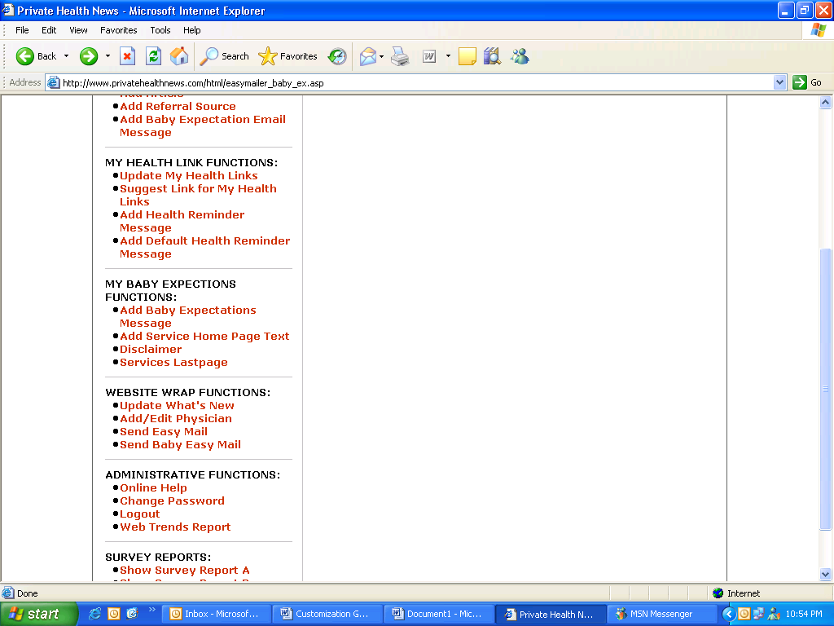

Then click…

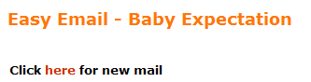

Select **Baby Easy Mail** from the Menu.

1. As in the **Health Newsletter Easy Mail**, select:
   1. **Date** that you’d like your message to be delivered
   2. Brief message for **Subject** line
2. Then, design your message in the frame as before, using text, graphics, hyperlinks and a call to action.

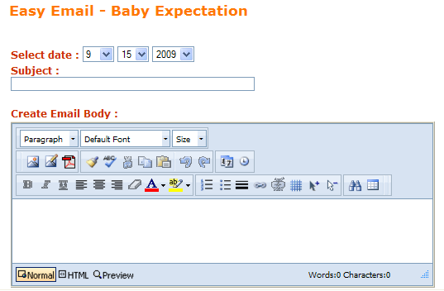

1. After your message is complete, decide how your message will be sent:
   * + - 1. You may select a pregnancy month, or choose months from 1-12 after baby’s birth.

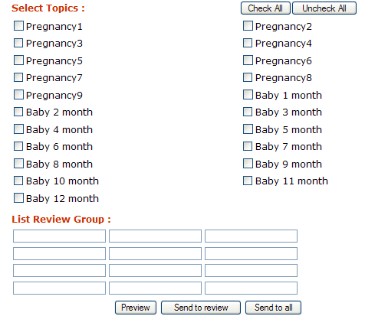

As with the Health Newsletter Easy Mail, you also have the option of sending the message to a review group before it is released to your subscriber base. To do this, design your message as before, and select at least one month. Your review group does not have to be subscribed to receive the emailed message.

1. After you have prepared your message and selected your audience, choose one of the following:
2. Click: **Send to All**. This saves and queues the email to be sent to the entire subscriber base, according to the parameters selected.
3. Click: **Send to Review**. This saves and queues the email to be sent. This email will be sent within a few minutes, unlike the **Send to All** option which is sent at 12:30 AM, EST on the date selected.

# AdHoc Functions

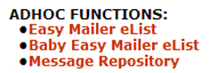

1. **Easy Mailer eList / Baby Easy Mail eList** - When consistently sending Easy Mail or Baby Easy Mail to the same group of content reviewers, you may enter the individual addresses into the eList for that feature. From that point on, these addresses are shown on the Add Easy Mail screen when setting up a new message. Then, simply click the email addresses of any reviewers you want to receive the test message. If sending to several of the pre-stored reviewers in the eList, hold down the Shift key while clicking on each of the email addresses. After clicking “Send to Review”, you’ll receive a confirmation that the review email was sent. A separate group of email addresses can be added to the Baby Easy Mail list**.  
     
   To add an email to the reviewer list:** 
   1. Type the email address that you wish to add in the **New Email:** field.
   2. Click: **Add New** if inserting a new address.
   3. Click: **Reset** to eliminate the email address that was entered in the

“New Email” box and begin again.

1. **To delete an email address if responsibilities change:**
   1. Click: **Del** next to the email address that you want to remove.
   2. When prompted “Are you sure you want to delete the selected

email, click “**Ok”**.

**Message Repository – This feature** can save you time if you inadvertently remove a message that you would like to use again. The Message Repository automatically stores the last five “saves” that are done in each of the editors. After clicking the feature from the main menu, you may then select which type of message you’d like to review: General Message: Web/Email, or Topic Message. From there you can select the date that you want to review, and if needed, cut/paste the message into another editor.

# Administrative Functions

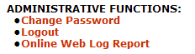

**Change Password** allows you to update your password. You cannot change the user name.

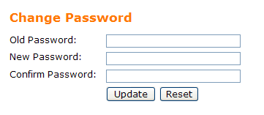

1. Click: **Change Password.**
2. Type in **Old Password**.
3. Type in **New Password**.
4. Type **New Password** again to confirm.
5. Save your changes:
   1. **Update** to update saves new password.
   2. **Reset** clears the form.

**\* Record your new password on page 6 of this manual for reference.**

**Logout:** Once you have completed your customizations, logout of the administration site. **Logout** exits you from the administrative site and returns you to the main page of your wrap site.

1. Click: **Logout**. You are returned to your main wrap site.
2. Close remaining open Internet sessions.

**NOTES**

|  |
| --- |
|  |
|  |
|  |
|  |
|  |
|  |
|  |
|  |
|  |
|  |
|  |
|  |
|  |
|  |
|  |
|  |
|  |
|  |
|  |
|  |
|  |
|  |
|  |
|  |